**WADS LAB TASK 10**

**27-02-2025**

*Sai Ganesh Eswaraprasad*

*HU22CSEN0100287*

1. Object from JSON String

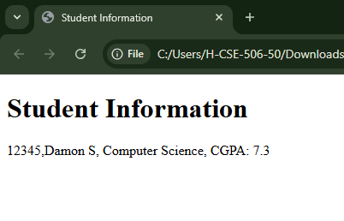

[CODE]

<!DOCTYPE html>

<html lang="en">

<head>

  <meta charset="UTF-8">

  <meta name="viewport" content="width=device-width, initial-scale=1.0">

  <title>Student Information</title>

</head>

<body>

  <h1>Student Information</h1>

  <div id="student-info"></div>

  <script>

    const jsonString = '{"pin": "12345", "firstname": "Damon", "lastname": "S", "course": "Computer Science", "cgpa": 7.3}';

    class Student {

      constructor(pin, firstname, lastname, course, cgpa) {

        this.pin = pin;

        this.firstname = firstname;

        this.lastname = lastname;

        this.course = course;

        this.cgpa = cgpa;

      }

      display() {

        return `${this.pin},${this.firstname} ${this.lastname}, ${this.course}, CGPA: ${this.cgpa}`;

      }

    }

    const studentData = JSON.parse(jsonString);

    const student = new Student(studentData.pin, studentData.firstname, studentData.lastname, studentData.course, studentData.cgpa);

    document.getElementById('student-info').innerText = student.display();

  </script>

</body>

</html>

1. Library Book Data Using JSON and JS

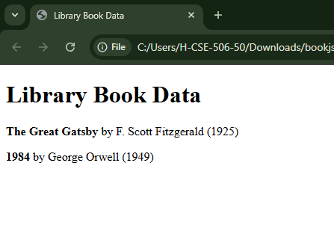

[CODE]

<!DOCTYPE html>

<html lang="en">

<head>

  <meta charset="UTF-8">

  <meta name="viewport" content="width=device-width, initial-scale=1.0">

  <title>Library Book Data</title>

</head>

<body>

  <h1>Library Book Data</h1>

  <div id="book-list"></div>

  <script>

    const booksJson = '[{"title": "The Great Gatsby", "author": "F. Scott Fitzgerald", "year": 1925}, {"title": "1984", "author": "George Orwell", "year": 1949}]';

    const books = JSON.parse(booksJson);

    function displayBooks() {

      const bookList = books.map(book =>

        `<p><strong>${book.title}</strong> by ${book.author} (${book.year})</p>`

      ).join('');

      document.getElementById('book-list').innerHTML = bookList;

    }

    displayBooks();

  </script>

</body>

</html>